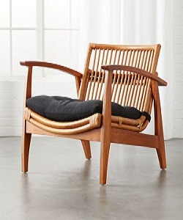

Simple Arm Chair

$9.80

Availability: In stock

### Description

Comfortable brown wood arm chair. Tufted cushion with Velcro straps in dark black and wipe with a soft, damp cloth. Warm mahogany frames a strong silhouette while Indonesian rattan curves to shape the back and seat. Extra plush tufted pad in dark grey sits cushy for long-term lounging. Cushion discreetly fastens with Velcro straps to keep from sliding.